**OS/Pathlib Info**

**os.listdir()** ……..lists every file in the current directory. Iterable i.e.

* Entry = os.listdir()
* For entry in entries:
  + Print(entry)……will print each file one at a time

**Can also use os.scandir(‘path here’)** to do the same as above

* os.scandir() returns an iterator rather than a list, so to see each file, you’d have to iterate over it via **for** loop

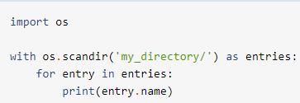

Use of context manager above means that once it has been used, Python will close it, and it will no longer take up any space in memory. Not necessary, though.

**List an Entire Directory Using Pathlib**

It is similar to the context manager we used above with **os.scandir()**.

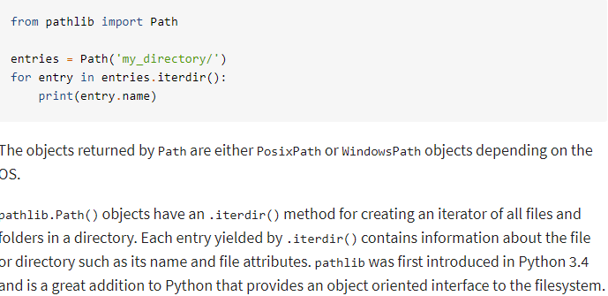

**List all Files in a Directory:**

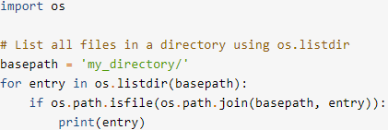

The call to os.listdir(basepath) or os.scandir(basepath) returns all items in the path, and then the call to os.path.isfile() filters them by whether or not they are a file (i.e. it won’t print out folders/directories)

**Example with os.scandir():**

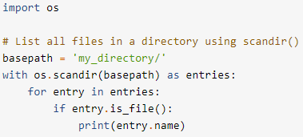

**Example with pathlib.Path():**

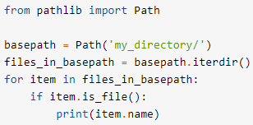

**NOTE:** you can just add “.iterdir()” to the end of the Path call in the basepath variable, rather than creating a new variable **files_in_basepath**

**Example with pathlib.Path() using a Generator Expression:**

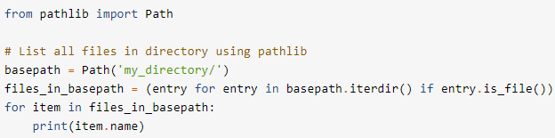

**Listing Subdirectories Instead of Files:**

**Example w/os.listdir() and os.path.isdir():**

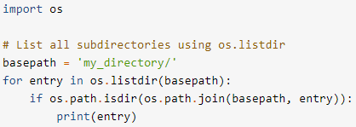

**Example w/os.scandir():**

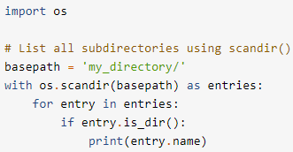

**Example w/pathlib.Path():**

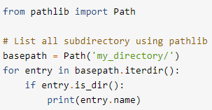

**NOTE:** you could just add “.iterdir()” to the end of the **basepath** variable

**Getting File Attributes:**

**Example w/ os.scandir():**

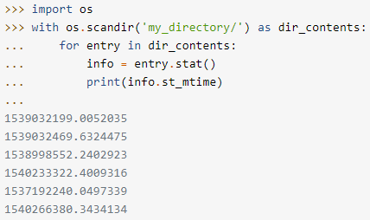

**Example w/pathlib.Path():**

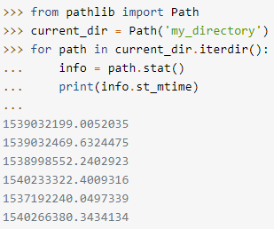

**Example of a helper function used to convert the Unix timestamp from os.scandir():**

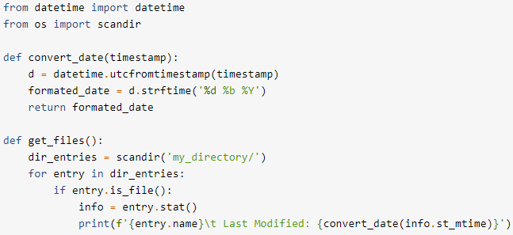

**How to create directories:**

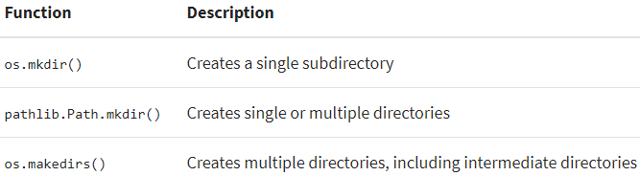

**Choices:**

**1).** Pass a path to **os.mkdir()**

**2).** Use pathlib.Path.mkdir()

x = Path(‘my_directory’)

x.mkdir()

When using mkdir(), it will throw a **FileExistsError** if the file already exists, so it may be a good idea, unless you are certain that it doesn’t exist, to handle the potential error in a try/except block:

Try:

p.mkdir()

Except FileExistsError:

Pass

**OR**

Pass in the “exist_ok=True” argument into .mkdir()

**Using glob.glob() to do File Pattern Matching**

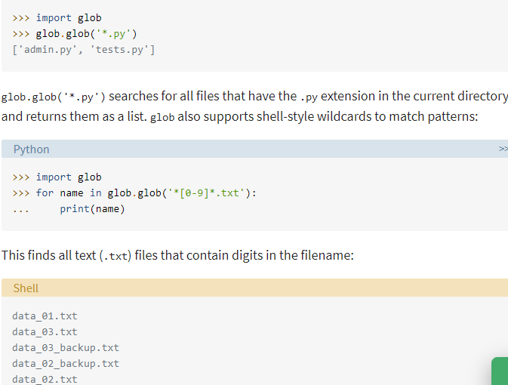

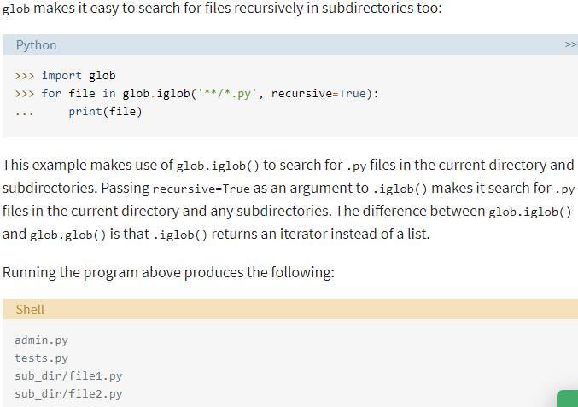

**Example of File Pattern Matching Using Pathlib**

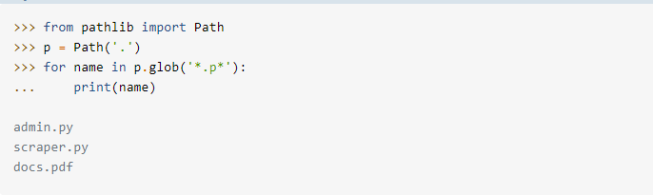

**Recap of File Pattern Matching Methods**

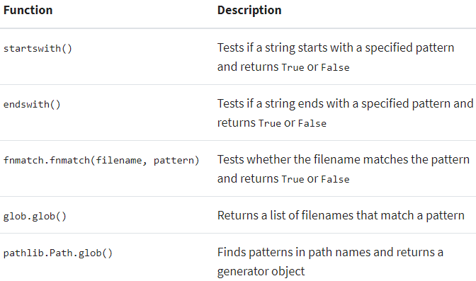

**Traversing File Directories and Processing Files with os.walk():**

**os.walk()** is used to generate a file name in a directory tree by walking the directory either top-down or bottom-up

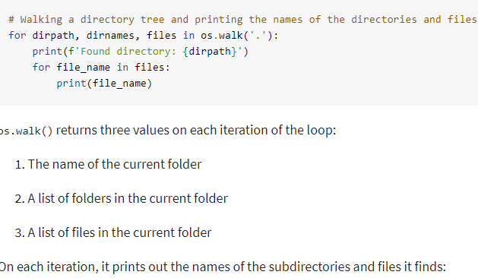

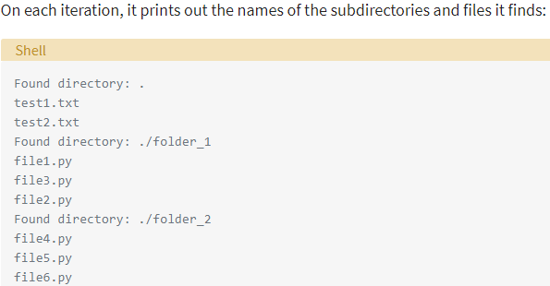

**Use os.walk() to traverse the file path in a bottom-up manner:**

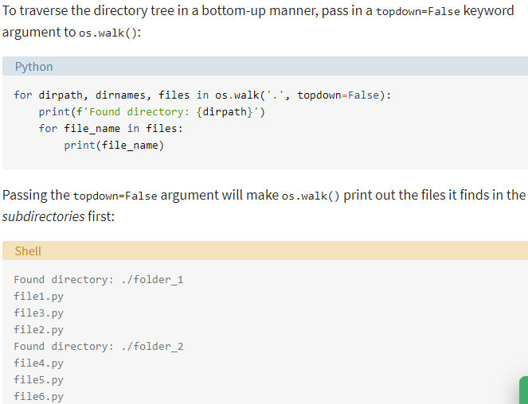

**Making Temporary Files and Directories**

**from tempfile import TemporaryFile**

The tempfile module allows you to open and store files in a temporary file or directory while your program is running, and handles the deletion/closing of the tempfile when your program terminates.

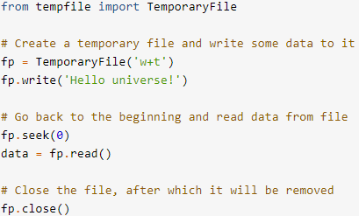

1). Create a **TemporaryFile** instance, and pass it the modes you want to access it in **i.e. (‘w+t’)**

2). Call write on the instance to write to the tempfile, pass in your string

3). fp.seek(0) = go back to the beginning of the file

4). data = fp.read() = read the data in the file, starting at the beginning

5). fp.close() = close the file, and the tempfile module will take care of deleting it

**NOTE: If you need to name your temporary file, use tempfile.NamedTemporaryFile () instead of tempfile.TemporaryFile()**

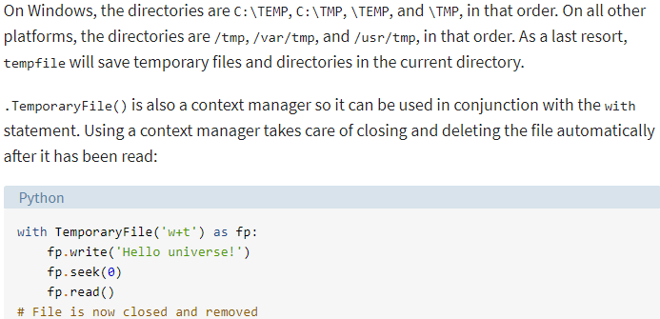

**Create a Temporary Directory:**

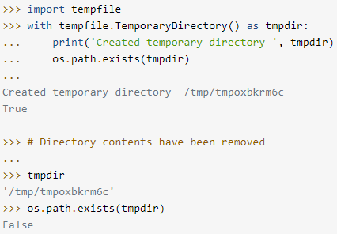

**Deleting Files and Directories**

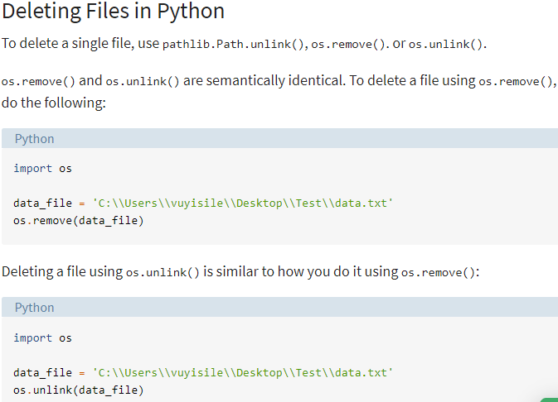

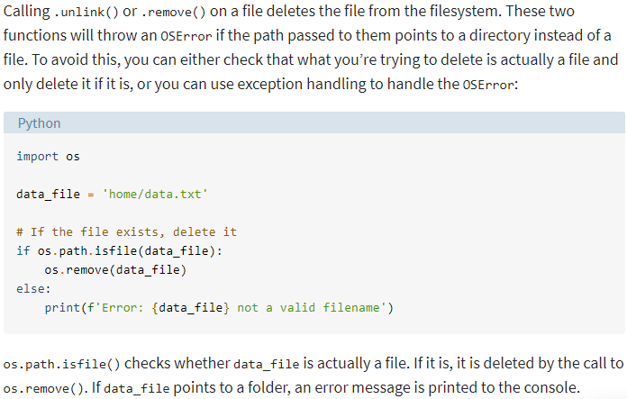

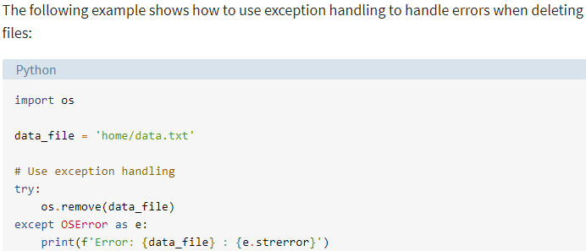

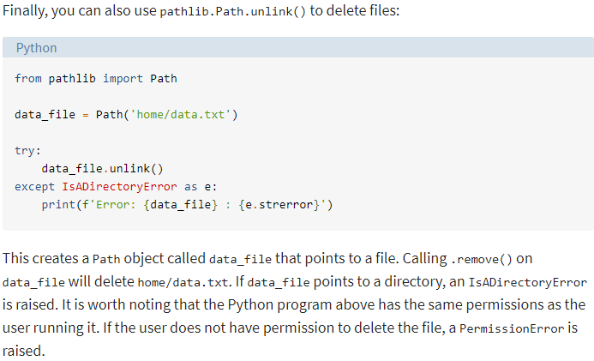

**How to Delete Directories**

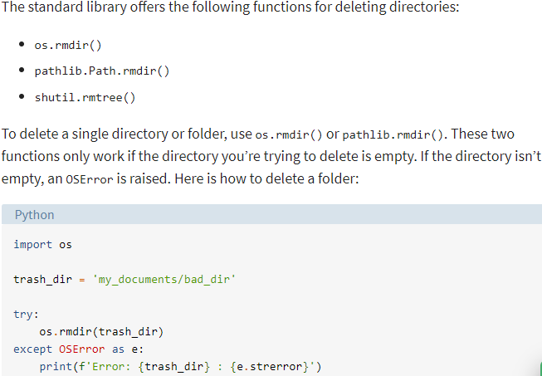

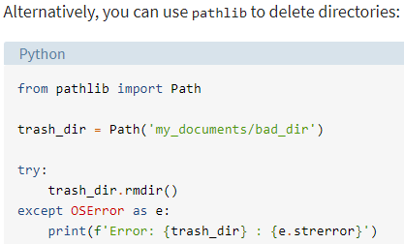

**Use Shutil to Delete Non-Empty Directories or Entire Directory Trees**

Use **shutil.rmtree()** to delete a non-empty directory or an entire directory tree:

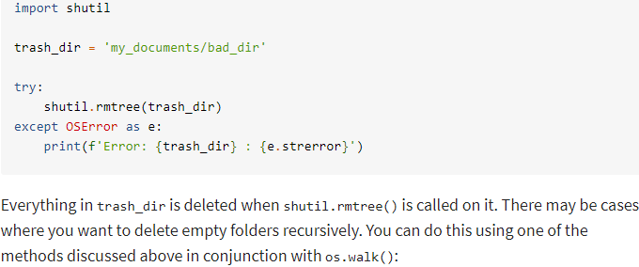

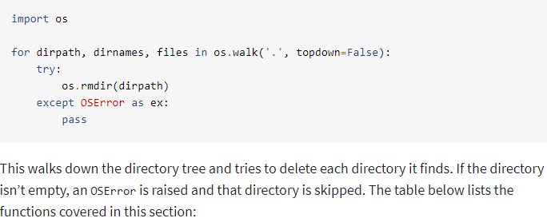

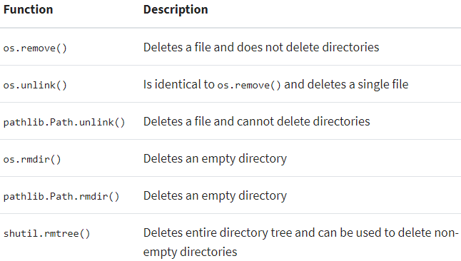

**How to Copy Files Using Shutil**

**Difference between shutil.copy() and shutil.copy2():** Both methods copy a file, but .copy2() saves file metadata, such as date last accessed, date created, etc.

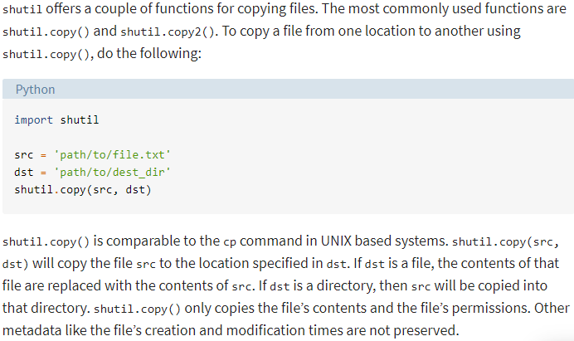

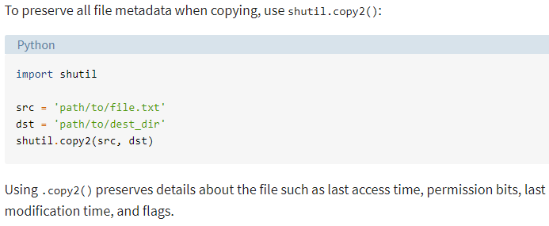

**How to Copy an Entire Directory Using shutil.copytree()**

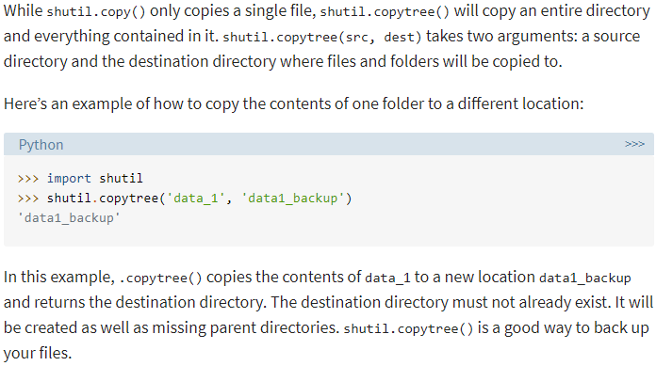

**Move Files Using shutil.move()**

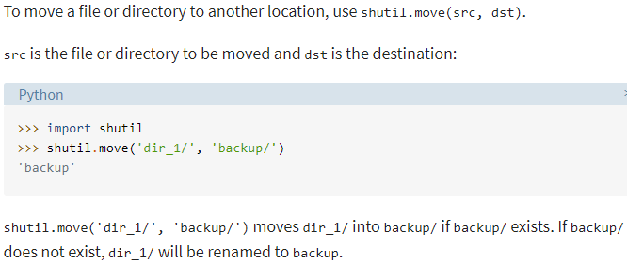

**Move Files Using os.rename()**

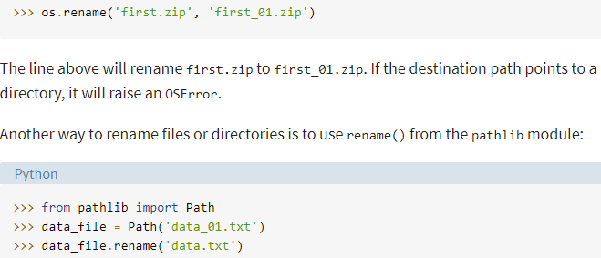

**Move/Rename Files Using pathlib.Path.rename()**

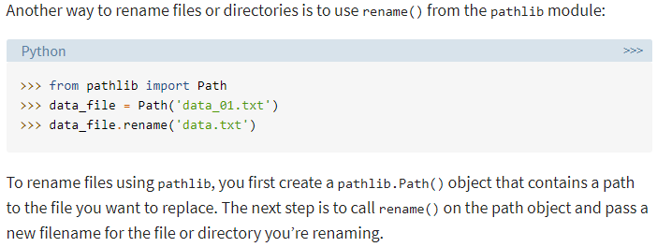

**Archiving: Reading and Writing ZIP and TAR Files**

